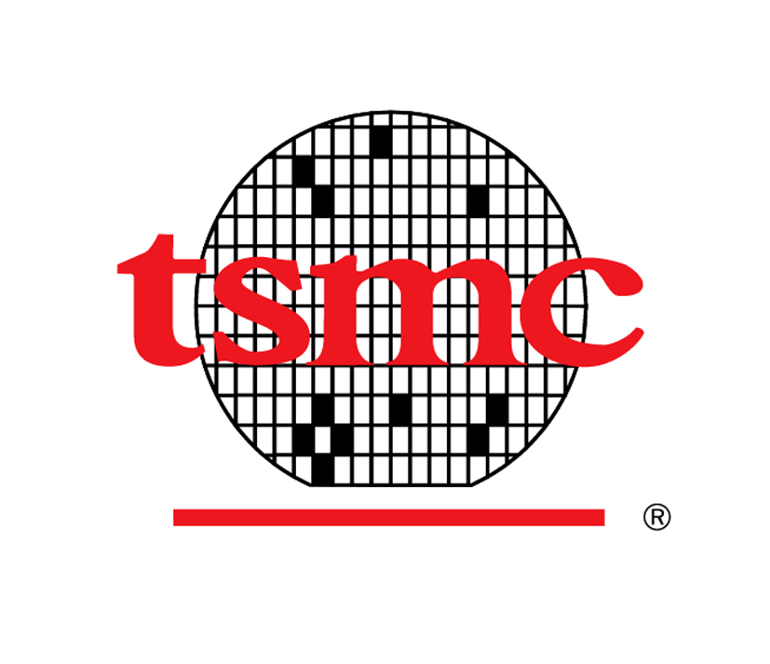
Taiwan Semiconductor Manufacturing Company, Ltd.

Personnel Information Form
人事資料表

TSMC Use Only  台積內部填寫 |  |  |  | Payroll No. |  |  |  |  |  |  |  |  |  |  |  |  |  | Dept. |  |  |  |  |  |  |  |  |  |  |  |  |  | Date Employed |  | mm/dd/yyyy  西元月/日/年
* Please fill out the form in English or Chinese 請使用英文或中文填寫此資料表
Job Applied For  申請職務 |  |  |  | 1. |  |  |  |  |  |  |  |  |  |  |  |  |  |  |  |  |  |  |  |  |  |  | 2.

A. General Information 個人基本資料
Name  姓名 | Chinese  中文 |  |  |  |  |  |  |  |  |  |  |  |  |  |  |  |  |  |  | Nationality  國籍 |  |  |  |  |  | □ R.O.C. 中華民國 |  |  |  |  |  |  |  | Photo  照片
Name  姓名 | English  英文 |  |  |  |  |  |  |  |  |  |  |  |  |  |  |  |  |  |  |  |  |  |  |  |  | □
Birth Date  出生日期 |  |  | mm/dd/yyyy  西元月/日/年 |  |  |  |  |  |  |  |  |  |  |  |  |  |  |  |  | Birth Place  出生地
Blood Type  血型 |  |  | □ A □ B □ O □ AB □ RH |  |  |  |  |  |  |  |  |  |  |  |  |  |  |  |  | Gender  性別 |  |  |  |  |  | Male男 □ Female女 □
I.D. No.  身分證字號 |  |  |  |  |  |  |  |  |  |  |  |  |  |  |  |  |  |  |  | Marital Status  婚姻 |  |  |  |  |  | Single未婚 □  Married已婚 □
Mailing Address  通訊地址 |  |  | □□□ |  |  |  |  |  |  |  |  |  |  |  |  |  |  |  |  |  |  |  |  |  |  |  |  |  |  |  |  |  |  | Tel ( )
Permanent Address  戶籍地址 |  |  | □□□ |  |  |  |  |  |  |  |  |  |  |  |  |  |  |  |  |  |  |  |  |  |  |  |  |  |  |  |  |  |  | Tel ( )
E-mail Address  電子郵件 |  |  |  |  |  |  |  |  |  |  |  |  |  |  |  |  |  |  |  |  |  |  |  |  |  |  |  |  | Cellphone  行動電話
Military Service  兵役狀況  若選擇男性，則為必填 |  |  | Service  軍種 |  |  |  |  |  |  |  |  | Rank  軍階 |  |  |  |  |  |  |  |  | Status  狀況 |  |  |  |  |  |  |  | Period  期間 |  |  | From起 Yr年 M月  To迄 Yr年 M月
 |  |  | Certificate No.  退伍令字號 |  |  |  |  |  |  |  |  |  |  |  |  |  |  |  |  |  | Reason of Exemption & Certificate No.  免役原因及證明字號

B. Education & Personal Interest 教育與個人興趣
Grade  階段 |  | Name of School  學校名稱 |  |  |  |  |  |  |  |  |  | Location  地點 |  |  |  |  | Major  科系 |  |  |  |  | From起 |  |  |  |  |  | To迄 |  |  |  | Graduated  是否畢業 |  |  | Type  日/夜間部 | Highest Degree  最高學歷
 |  |  |  |  |  |  |  |  |  |  |  |  |  |  |  |  |  |  |  |  |  | M月 |  |  | Yr年 |  |  | M月 |  | Yr年 |  | Yes | No |  | Type  日/夜間部 | Highest Degree  最高學歷
High School  高中(職) |  |  |  |  |  |  |  |  |  |  |  |  |  |  |  |  |  |  |  |  |  |  |  |  |  |  |  |  |  |  |  |  |  |  | □Day 日間部  □Night夜間部
Jr. College  專科 |  |  |  |  |  |  |  |  |  |  |  |  |  |  |  |  |  |  |  |  |  |  |  |  |  |  |  |  |  |  |  |  |  |  | □Day 日間部  □Night夜間部
University  大學 |  |  |  |  |  |  |  |  |  |  |  |  |  |  |  |  |  |  |  |  |  |  |  |  |  |  |  |  |  |  |  |  |  |  | □Day 日間部  □Night夜間部
Post Graduate
(Master)
研究所(碩士)
Post Graduate
(PhD)
研究所(博士)
Other
其他

Describe any special vocational or technical training and specialized knowledge/skill 請說明您的專業知識與技能

In summary, key words of your expertise are: 您專業技能的關鍵字詞為何(註：關鍵字有助於迅速搜尋相關人才)

Personal Interests & Hobbies個人興趣、嗜好

License or Certificate  專業證照或檢定證書 |  |  |  |  |  |  |  |  |  |  |  |  |  |  |  |  |  |  |  | Date of Issue  發照日 |  |  |  |  |  |  |  | Certificate No.  證照字號 |  |  |  |  |  | Remarks  備註

C. Working Experience (It is at your discretion to provide the information of supervisor and compensation.)

工作經驗 (直屬主管及薪資資料請自行斟酌是否填寫)
From 起 |  | To 迄 |  |  | Title /  On Grade Year  職稱/在職年資 |  |  | Co. Name  公司名稱  (請填入公司全名) |  |  |  |  |  | Co. Location  (Country)  公司所在地點 |  |  |  |  | Supervisor  直屬主管 |  |  |  |  |  |  | Compensation 薪資 |  |  |  |  |  |  |  |  |  | Reason  for Leaving  離職原因
M月 | Yr年 | M月 | Yr年 |  |  |  |  |  |  |  |  |  |  |  |  |  |  |  | Name  姓名 |  |  | Title  職稱 |  |  |  | Monthly Base Salary 月薪 |  |  |  |  |  | Allowance  /Bonus  津貼/獎金 |  | Others  其他 |  | Reason  for Leaving  離職原因
May we contact your present employer? 台積公司是否可與您的現任雇主聯絡查證 □ No否 □ Yes是
We shall not do so without your consent. 未經您同意台積公司絕不會聯絡您的現任雇主
Describe your experience, major achievement during each of the period mentioned above.
請摘要您於上述各職務的主要成就

Language Ability: indicate the language and your proficiency, i.e. Excellent, Good, Useful, A little, Not at all.
語文能力：請以極佳、佳、普通、略通或不通說明您對該語文的熟練程度
Second Language and so on第2、3...外國語 |  |  |  |  |  |  |  |  |  |  |  | Read 讀 |  |  | Write 寫 |  |  |  |  |  |  |  | Speak 說 |  |  |  |  |  |  | Remarks備註
1. English
2.
3.
English typing speed 英打速度 W/M(字/分) |  |  |  |  |  |  |  |  |  |  |  |  |  |  |  |  | Chinese typing speed 中打速度 W/M(字/分)

D. Others 其他
Family Information (including parents, parents-in-law, guardian, spouse, children & siblings)
家庭資料(父母、 岳父母、監護人、配偶、子女及兄弟姊妹)
Relationship  關係 |  |  |  | Name 姓名  (可使用中文) |  |  |  |  |  | Age  年齡 |  |  | Occupation 職業 |  |  |  |  |  |  | Address 住址  (可使用中文) |  |  |  |  |  |  |  |  |  |  |  |  |  |  | Tel 電話
Father父
Mother母
Spouse配偶
Children 子女
Do you have any relatives or friends working in tsmc? 目前是否有任何親屬、朋友任職於台積公司？
□ No 否 □ Yes 是 If yes, please specify the name, relation and dept. 如有，請列出姓名、關係及任職部門
Name 姓名  (可使用中文) |  |  |  |  |  | Relation  關係 |  |  | Department  部門 |  |  |  |  |  |  |  | Name 姓名  (可使用中文) |  |  |  |  |  |  |  | Relation  關係 |  |  |  |  |  | Department  部門
Reference Check 資歷查核 (Please provide minimum of three names. Your research advisor(s), colleagues, or supervisor(s) must be included in.) 請至少提供三位查核對象，其中至少須含論文指導教授、授課教師、同事或直屬主管)
Name 姓名  (可使用中文) |  |  |  |  |  | Relation  關係 |  |  |  |  | Company / Dept.  公司/部門 |  |  |  |  | Title  職稱 |  |  |  |  | Contact聯絡方式
 |  |  |  |  |  |  |  |  |  |  |  |  |  |  |  |  |  |  |  |  | (Tel)  (Cell) |  |  |  |  |  |  |  | E-mail:
 |  |  |  |  |  |  |  |  |  |  |  |  |  |  |  |  |  |  |  |  | (Tel)  (Cell) |  |  |  |  |  |  |  | E-mail:
 |  |  |  |  |  |  |  |  |  |  |  |  |  |  |  |  |  |  |  |  | (Tel)  (Cell) |  |  |  |  |  |  |  | E-mail:
Person to notify in case of emergency 緊急聯絡人
Name 姓名  (可使用中文) |  |  |  |  |  | Relation  關係 |  |  |  |  | Address 地址  (可使用中文) |  |  |  |  |  |  |  |  |  |  |  |  |  |  |  |  | Tel/Cell

What do you expect most of the job that you are applying for? Please tick and explain briefly.
您對下一份工作最重視的項目為何，請勾選並簡要說明
Aspect 項目 |  |  |  |  |  |  | Why 原因 |  |  |  |  |  |  |  |  |  | Aspect項目 |  |  |  |  |  |  |  |  |  | Why原因
□ Greater responsibility  擔負更大的責任 |  |  |  |  |  |  |  |  |  |  |  |  |  |  |  |  | □ New field of work新領域
□ Salary薪資 |  |  |  |  |  |  |  |  |  |  |  |  |  |  |  |  | Opportunities of learning□ & development  訓練與發展的機會
□ Job security工作保障 |  |  |  |  |  |  |  |  |  |  |  |  |  |  |  |  | □ Different location  工作地點
□ Others其他
When will you be available for the new job if you are recruited? 如獲任用何時可以報到  Yr年 M月 Date日 |  |  |  |  |  |  |  |  |  |  |  |  |  |  |  |  |  |  |  |  |  |  |  | Expected Salary  期望薪資 |  |  |  |  |  |  |  |  | NT$
Are you qualified for the below status as specified by law (Optional)? 您是否具有以下之法定身分 (非必填) :
□原住民 Indigenous people □身心障礙者 Individuals with disabilities

Which channel did you learn the job opening? 您自何處得知此職缺
□ Campus 學校 □ Job bank人力銀行 □ Newspaper ad.報紙廣告
□ Magazines 雜誌 □ Friends / Relatives親友 □ Teachers/Advisors 授課教師/指導教授
□ Employment Service Office 就業輔導站 □ Others 其他，請說明___________________
Additional information you wish to add 其他補充資訊 |  |  |  |  |  |  |  |  |  |  |  |  |  |  |  |  |  | Have you ever committed crimes and been plead a charge?  您是否有任何犯罪紀錄或遭受起訴？  □ No否 □ Yes是 What請說明 ___________________  Are you on the wanted list? 是否遭任何國家通緝？  □ No否 □ Yes是 What請說明________________
I hereby authorize TSMC to confirm the accuracy of all statements made on this form, and I fully understand that any false statements made herein will be sufficient cause for employment termination. I hereby agree and authorize TSMC to collect, handle, and use the personal information which I have provided or will provide in accordance with relevant laws about personal information protection, for purpose of TSMC's personnel management.
本人玆此授權台積公司得就本人在此陳述之內容真實性，進行確認；本人完全瞭解，任何不實陳述依法將足以構成聘僱關係之終止。本人並同意授權台積公司基於人事管理相關業務上之目的，得在符合個人資料保護相關法令之規定範圍內進行蒐集、處理、使用本人所提供之個人資料。

Signature 簽名 Date 日期
I hereby declare that I will comply with all TSMC regulations during my employment. In case of any violation, I agree to accept and be bound by applicable penalties as specified in the TSMC Work Rules and relevant rules.
本人同意並保證：本人於在職期間將遵守台積公司所有相關規定。如有違反，本人同意接受工作規則及其他相關規定之懲處。

Signature簽名 Date日期

