Construction Notice

Date | 2026/3/9~2026/3/27
Time | 8:00 a.m. to 6:00 p.m.
Place | Veterinary Medicine Teaching Hospital
Explanation | Second scaffolding dismantling will be carried out for the new construction project of the International Veterinary Disease Prevention Training Center and Veterinary Teaching Hospital Building. All faculty, students, and visitors are requested to follow on-site notices, refrain from parking in the construction area, nearby parking lots, and sidewalks, and comply with traffic control arrangements. Noise may occur during the construction period; your understanding is appreciated. Work will be rescheduled in the event of a typhoon or heavy rain.
Office | Construction and Maintenance Division, Office of General Affairs
Contact Us | 04-22840276-279

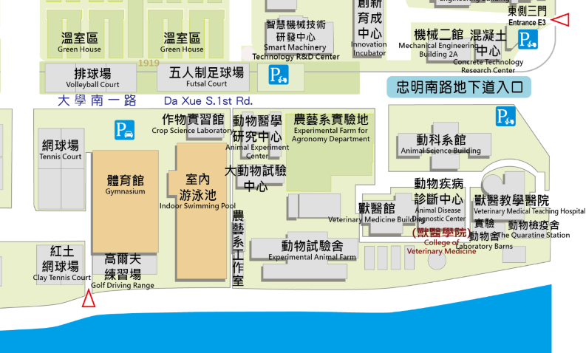
Construction Notice

2026/3/9~2026/3/27 8:00 a.m. to 6:00 p.m.
Second scaffolding dismantling will be carried out for the new construction project of the International Veterinary Disease Prevention Training Center and Veterinary Teaching Hospital Building.

