※ Power Outage Notice (2024/02/03) ※
國立中興大學
National chung hsing university
總 務 處
General Affairs Office
營 繕 組
Division of Construction and Maintenance

DATE | 2024/02/03
TIME | 1:30 p.m. to 4:45 p.m.
PLACE | Teaching Complex Building, Agricultural & Environmental Science Building and Social Science & Management Building.
Explanation | Please inform all personnel and turn off relevant electrical equipment. For safety reasons, please do not start electrical or computer equipment or take elevator during the suspension of power supply. We apologize for any inconvenience caused and appreciate your patience and support.
Office | General Affairs Office Division of Construction and Maintenance
Contact Us | 04-22840276-279

2024/01/29

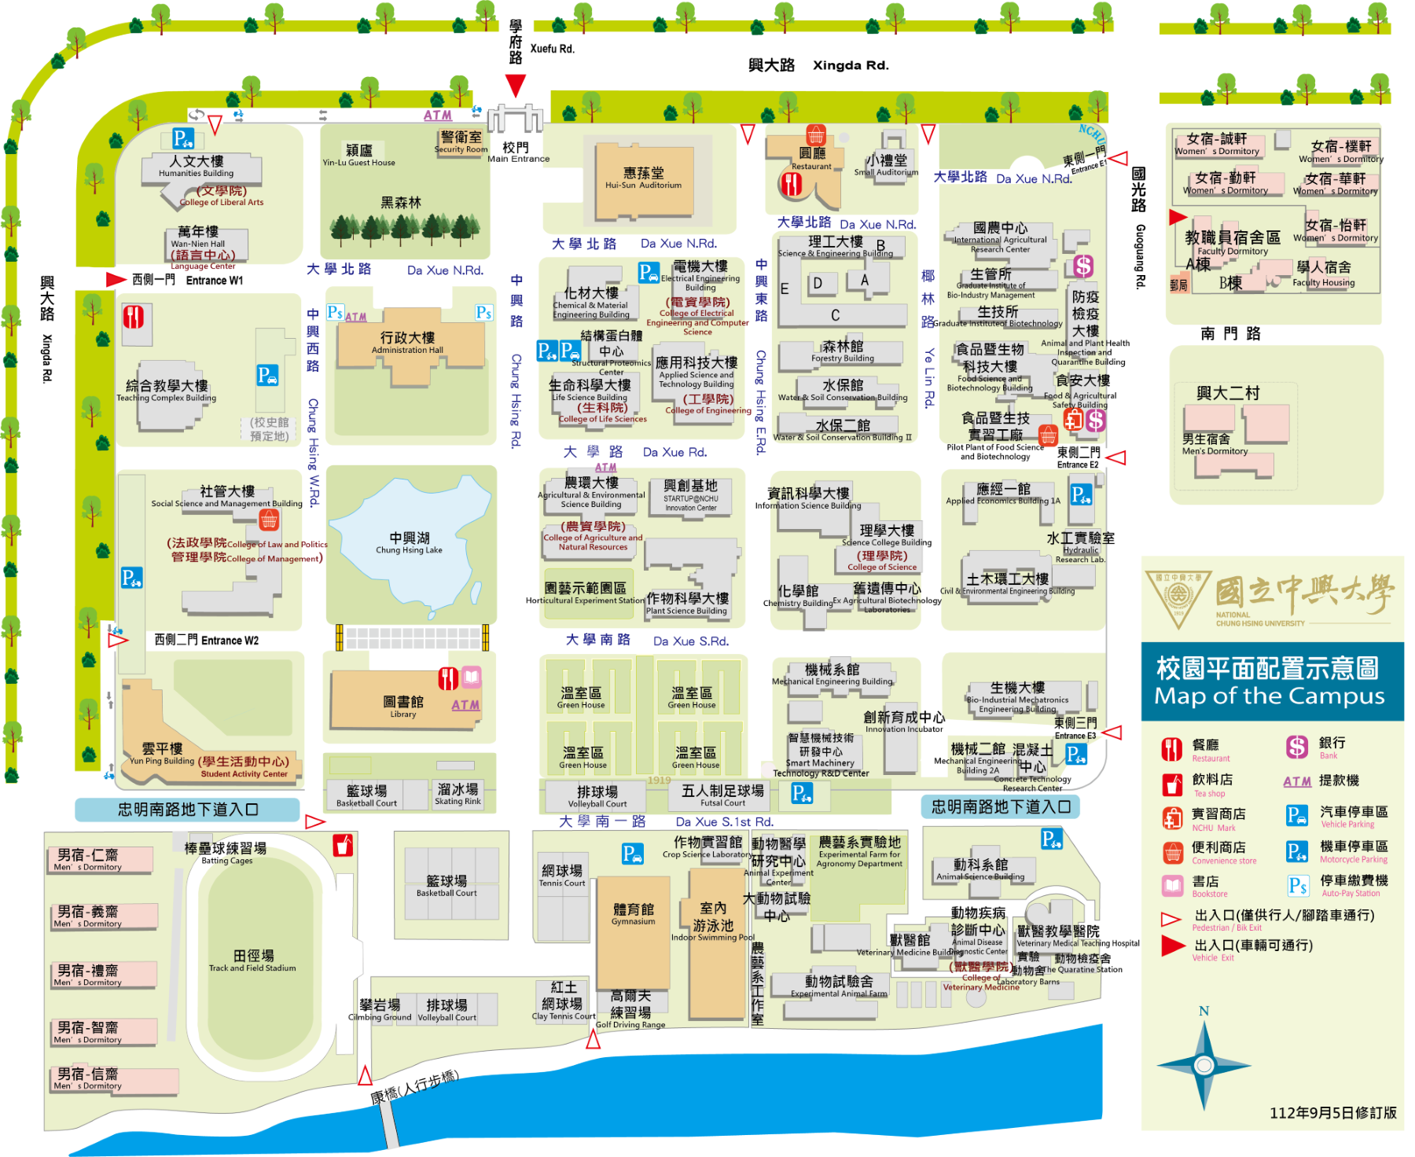
※ Power Outage Notice (2024/02/03) ※
※ Power Outage Notice 2024/02/03
1:30 p.m. to 4:45 p.m.※

