Recruitment of Group Leaders for Library Chatsphere
Application Form

Personal Information
English Name |  |  |  | Please attach a recent photo here (Casual picture from daily life)
Chinese Name
Student ID
Department
Nationality
Cellphone
Line ID | Once the group lists are finalized, contact information for each group member and the leader will be provided to people within the group.
E-mail
Date of expiration of ARC
Date of expiration of Work permit
※To process your salary payments, please ensure that your ARC and work permit are valid in December 2024 or January 2025, when payments will be made. It is not necessary for these documents to be valid during the activity itself.
To be a group leader
Experiences |  | ※Have you had any experience in facilitating small group discussions?
Purpose of applying the leadership
Your Group’s SDG Goal
Group Name
Introduction about your group topic (below 200 words) |  | ※The introduction will be provided to members during the registration for reference. The leader can suggest several potential discussion topics related to the chosen SDG. These could just be initial ideas. During the orientation, further refinements and adjustments can be made.
Available Time |  | Please conduct at least 5 sessions starting from 10/19 to 12/8, with each lasting for 90 minutes. Please fill in your preferred time in order, the library will display the time to members when signing up.  (e.g. Monday 17:30-19:00, Friday 14:00-15:30, Saturday 10:00-11:30)
 |  | ①
 |  | ②
 |  | ③
Leader Training & Orientation |  | ※A 3-hour leader training will be held between 2024/10/7 and 10/11 and an orientation will take place between 10/14-10/18. To help us schedule and accommodate the availability of professors and other leaders, please provide any inconvenient times during these weeks (including evenings). This will help us arrange the training more effectively.  10/7-10/11 & 10/14-10/18 inconvenient times:
Record a Video  (2-3minutes) |  | ※The video is expected to include a self-introduction, the group topic, and how you plan to lead the group.  - Please upload your video to YouTube  - paste "Introduction about your group topic" to the description of the video  - set the visibility to "Unlisted"  - paste the URL here  URL:_________________________________________  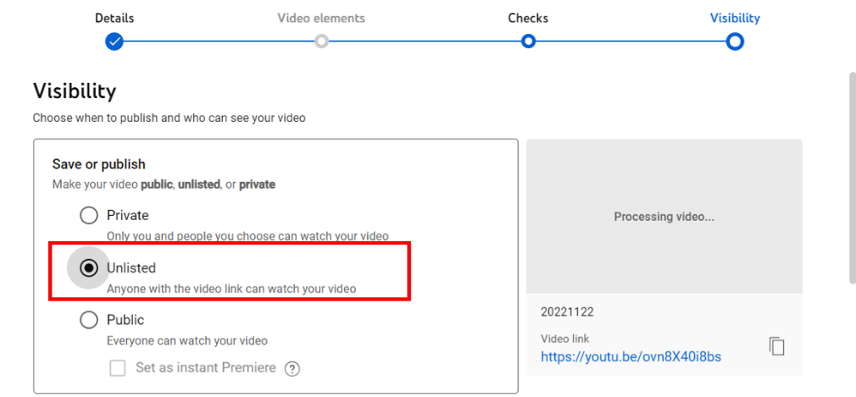
Others |  | ※By ticking the box below, you consent to having your photos and videos used for public announcements if selected as a leader for the Library Chatsphere. We require all leaders to provide these materials, which will be used solely to help students make informed choices when selecting their teams during registration.  □ Accept

※Please email your application to mhhou@dragon.nchu.edu.tw before 2024/9/17, with the title “Application for group leader-OOO(Name). For more information, please contact the same email address above.

